1) Paper identity
- Title: SCHIZOPHRENIA detection from EEG data using IMAGE ENCODING
- Year / Venue : 2025 / Scientific report
- Authors : Utathya Aich, Arghyasree Saha, Marcin Woźniak, Muhammad Fazal Ijaz, Pawan Kumar Singh.
- Problem statement: Overcoming the Subjective clinical evaluation which leads to misdiagnosis by using objective, automated diagnostic framework using EEG data .
- Task type: Diagnostic support / Screening
- Target population: Adolescents and Adults .
2) What is being predicted
- Label/output: Binary (Schizophrenia vs Normal People)
- Label source: Clinician diagnosis.
- Prediction time horizon: Single session.
- What “positive” means: The person belongs to Schizophrenia group based on the brain wave patterns.
3) Modalities + signals used
- ✅ MRI / EEG / physiological data: Used EEG signals.
- ❌Tabular data
- ❌ Video
- ❌ Audio / speech
- ❌ Text
- Capture setup: Scalp electrodes (16 channels) measuring electrical activity in microvolts.
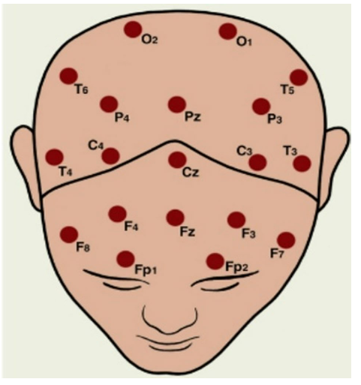
- Task Elicitation: Standard resting-state or clinical EEG recording.
4) Dataset facts (must be precise)
- Dataset 1:
- MSU DATASET ( Moscow State University ) : http://brain.bio.msu.ru/eeg_schizophrenia.htm or https://www.kaggle.com/datasets/kacharepramod/eeg-schizophrenia
- Total subjects:
84 ( 45 schizophrenia, 39 normal )
- Total samples/recordings:
EEG segmented into artifact-free 30-second segments
Converted into 12,096 scalogram images
Sliding window: 20 s window, 15 s overlap
- Train / Validation / Test Split
80% training, 20% testing
- Demographics:
Country: Russia
Age group: Adolescents
- Inclusion / Exclusion
Inclusion: Clinically diagnosed schizophrenia and healthy subjects
Exclusion: EEG segments with artifacts (eye movement, muscle, ECG)
- Leakage Risk: Low

- Dataset 2 :
- RepOD DATASET : https://www.kaggle.com/datasets/srinivasapanchavedi/eeg-data-for-schizophrenia
- Total subjects:
28 ( 14 schizophrenia, 14 normal )
- Sampling :
15-minute EEG per subject
Converted into 89,830 scalogram images
Sliding window: 20 s window, 15 s overlap.
- Train/Test:
80% training, 20% testing
- Demographics :
Gender: Balanced
Age: Adults
- Inclusion / Exclusion
Inclusion: Clinically diagnosed schizophrenia and healthy subjects
Exclusion: EEG segments with artifacts (eye movement, muscle, ECG)
- Leakage Risks: No as its controlled
5) Preprocessing (replication critical)
- Cleaning: 2nd-order Butterworth filter to isolate frequency bands (Delta, Theta, Alpha, Beta, Gamma). Artifact-free segments selected.
- Segmentation: 20-second sliding windows with a 15-second overlap (5-second shift).
- Feature Extraction: Continuous Wavelet Transform (CWT) using Morlet Wavelet to generate Scalogram images (256 x 256 pixels).
- Removal of low – quality segments.
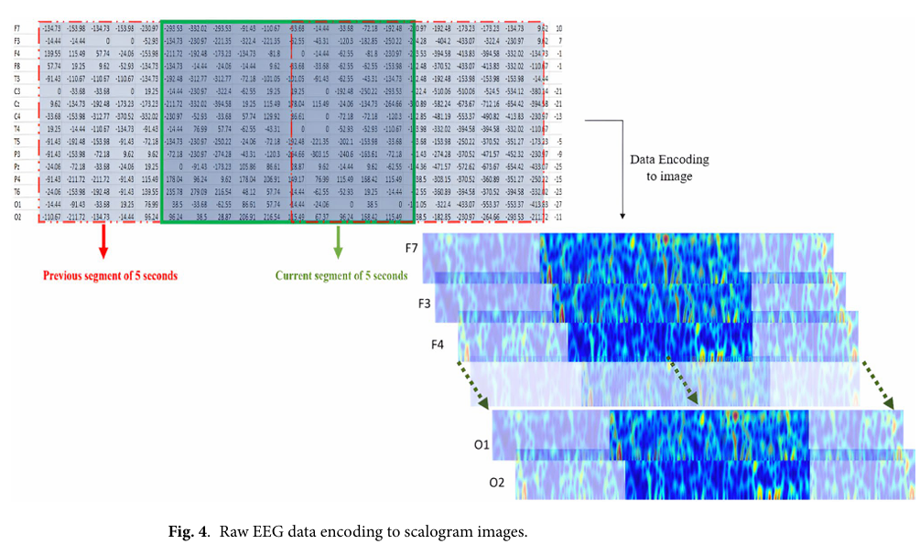
6) Model architecture (replication critical)
- Model type: Hybrid (Deep learning + ML Wrapper)
- Backbone: Dual-stream extraction using EfficientNetB3 and DenseNet169 (pre-trained on ImageNet).
- Fusion strategy:
  - Late fusion
  - Concatenation of features extracted from Global Average Pooling layers.
- What exactly is trained: Fine – tunned CNN layers with 30 epochs (one complete pass-through dataset), KNN classification within the Wrapper (ASBO).
- Model size: Lightweight.

7) Training recipe (must capture)
- Loss function(s): Categorical Crossentropy.
- Optimization: Adamax ( 0.001).
- Batch size, epochs, early stopping: 30 epochs for feature extraction and 100 ASBO iterations.
- Class imbalance handling : Balanced datasets .
- Hardware used (GPU type) and training time (if mentioned) : NVIDIA GPU T4 Kaggle .
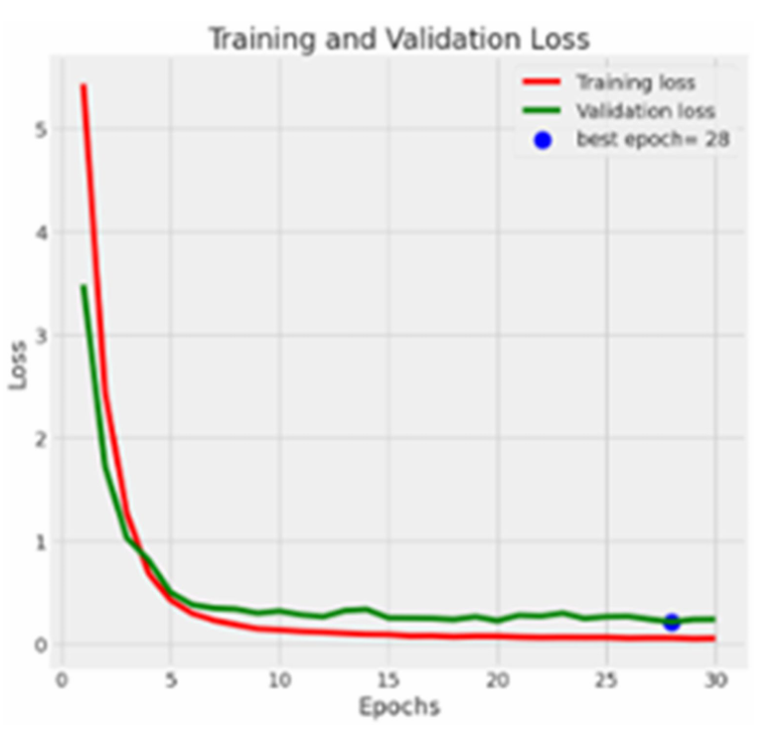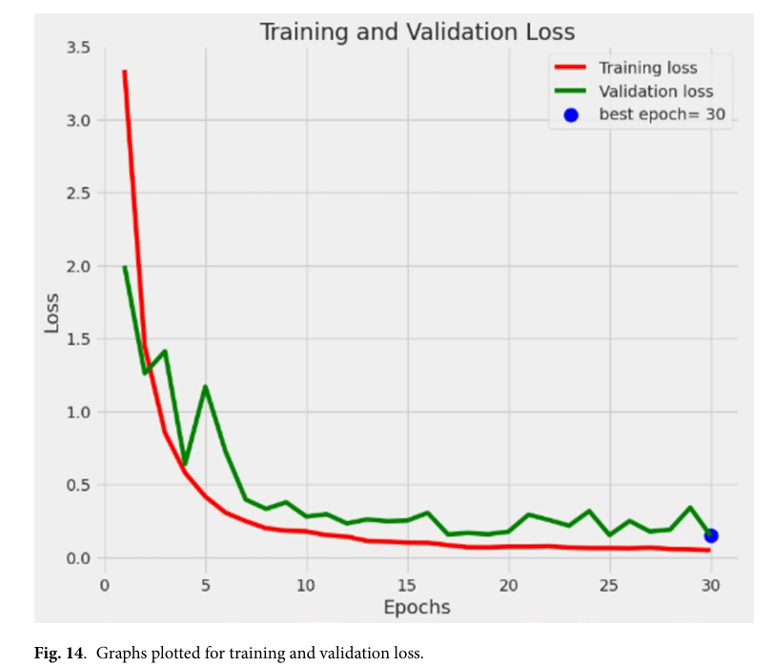
8) Evaluation protocol (must be strict)
- Primary metric (AUROC/AUPRC/F1/accuracy/MAE): Accuracy,F1-Score , Recall.
- Secondary metrics: Precision
- Cross-validation : test – train- split.
- Threshold : Default KNN threshold
- External validation dataset : Yes ( Result validation checked with two independent datasets)
9) Results snapshot (numbers + context)
- Main result table :
- MSU DATASET : 99.67% accuracy
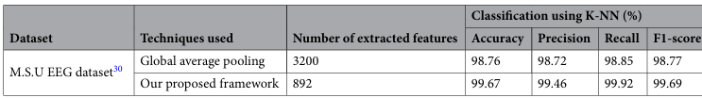
- RepOd DATASET: 99.97% accuracy
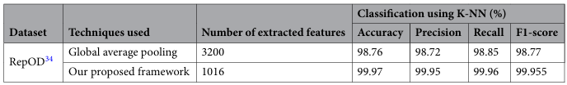

- Best baseline comparisons : Beats all the previous tested previous frameworks
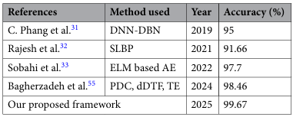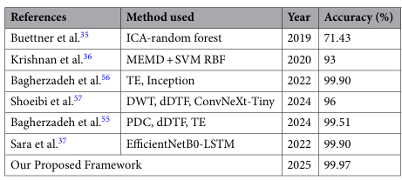
- Ablations: Shows that the concatenation features and the ASBO wrapper significantly outperformed individual models while reducing the complexity.
- Generalization claims: Strong supported by constant performance across datasets.
10) Interpretability / explainability
- Any explainability method used: NONE.
- What explanations are shown: Scalograms are used visually to demonstrate the difference between normal and schizophrenic person.
- Are explanations clinically meaningful: Vizualization of Delta/Alpha/Theta/Beta/Gamma bands in scalograms are used to justify the choice of CWT.
11) Reproducibility score (students must judge)
- Dataset availability: 5 , Both MSU and RepOD datasets are well known and public repositories .
- Method clarity: 4 , The work flow is clear but need high mathematical knowledge to replicate the ASBO feature selection and preprocessing parameters ( Morlet wavelet , Butterwort Filter).
- Compute feasibility: 5, Runs on the standard T4 GPU (free on Kaggle 30 hrs per week) .
- Replication readiness: 4.6, Reproducible given the clear pipelines of the format .
12) Productization notes (this is the key)
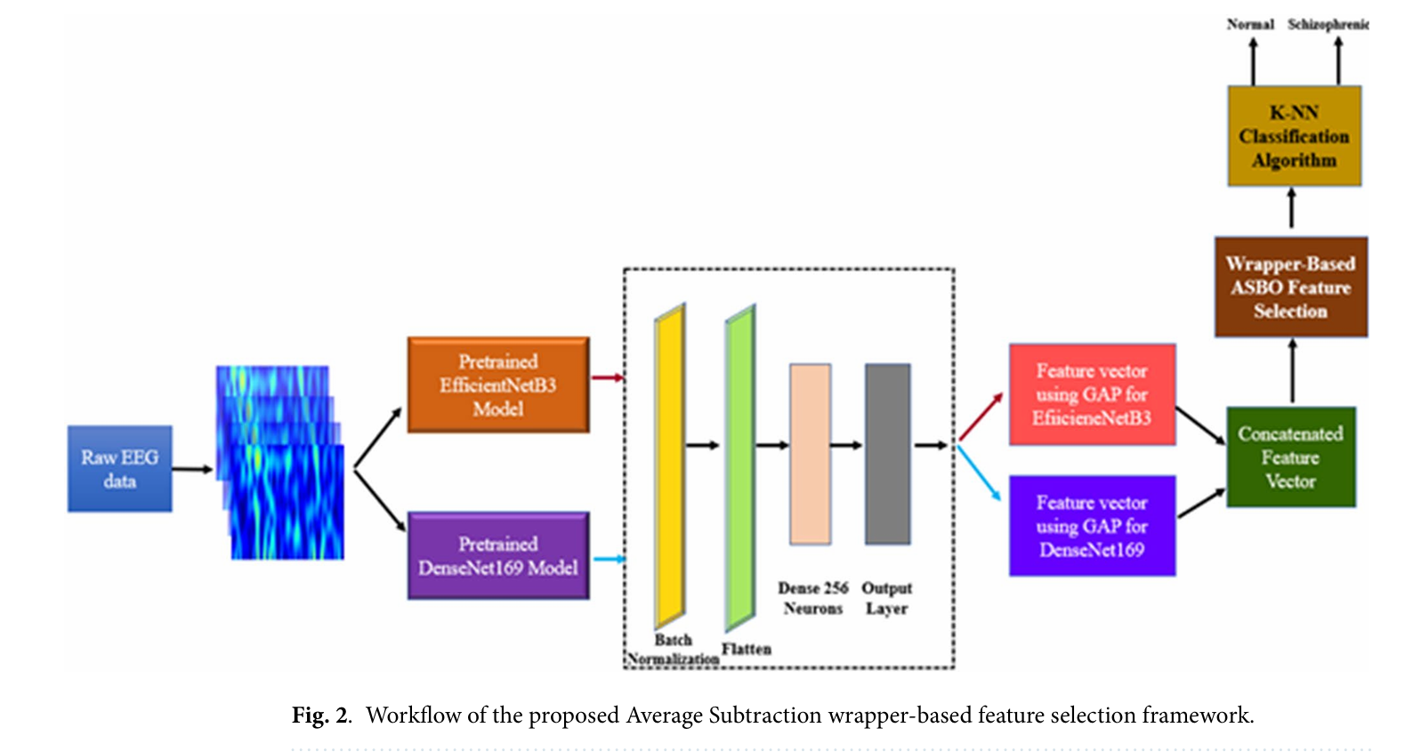
A) What would a real-world input look like?
- Raw EEG data stream from the 16-19 channel caps , requires lab equipment .
B) Minimum viable workflow (MVP):
- Patient preparation ( 10 min) EEG recording ( 15min) CWT conversion Cloud upload Diagnostic Score
- Time required < 30 min .
- Quality checks required : checking the working of the electrode of the caps and the signals
C) Output format:
- Binary classification with a confident score.
- Gives if the patient is normal or schizophrenic .
D) Constraints and risks:
- Bias towards adolescent and adult must be monitored.
- Sensitive clinical data .
- Need more verification as false positive and false negative can be observed.
- False positive could lead to misidentification, false negative delayed treatment.
E) Deployment feasibility:
- Cloud based API for hospital systems
- latency expectations: low due to light weight feature vector .
13) “Your proposed extension” (one concrete idea)
- We can add another Modality like speech verification as people with schizophrenia often show symptoms of formal thought disorder.
- We can convert the audio to spectrogram and apply the same process as that of scalogram to this spectrogram.
- This helps in catching the different parts of the illness and we can make it much scientifically believable to the doctor and improves the quality of the diagnosis.

